

Financial Management System with Machine Learning Support

Proposal

Caleigh Susan Anak Jeffry

Bachelor of Software Engineering with Honours
2025
Table of Contents
Contents
1.0 Project Title 1
2.0 Introduction 1
3.0 Problem Statement 1
4.0 Scope 2
5.0 Aims and Objective 3
6.0 Brief Methodology 4
7.0 Significance of Project 5
8.0 Project Schedule 6
9.0 Expected Outcome 6
10.0 References 7

Project Title
Financial Management System with Machine Learning Support

Introduction
Managing personal finances effectively as a student is an essential life skill. Nowadays, students often use digital transactions which leads to problem when it comes to organize their daily expenses and struggle to control their spending. This difficulty is further compounded for those who is sharing their daily expenses with friends. Hence, this project introduces Spendette, a web-based expense analyser designed to address these issues by integrating personal and group finance management within a single platform. Spendette allows users to record and monitor their daily expenditures while managing shared expenses for various purposes such as accommodation, trips, or group activities. This financial management system promotes transparency by ensuring that all members clearly understand their financial responsibilities. Furthermore, Spendette incorporates Machine Learning to analyse users’ historical spending data, identify behavioural patterns, provide personalized budgeting recommendations, and detect unusual or excessive expenses. This digital approach enables users to nurture better financial habits. The platform also features monthly spending trends to enhance users’ understanding of their financial behaviour. By integrating personal and shared financial management with predictive insights, Spendette offers an approach to financial organization that promotes responsible spending and strengthens financial literacy among its users.

Problem Statement
Limited financial literacy among young adults results in weak money management skills, as their insufficient understanding of financial matters hinders their ability to handle money effectively (Teo et al., 2013). This issue frequently happens among students that face difficulties in managing their financial efficiently especially tracking both of their personal and shared expenses. In addition, Irby (2024) mentioned that frequent small purchases can accumulate unexpectedly and result in budget overruns, therefore, systematically tracking expenses through receipt collection and categorized spending records enables individuals to identify and manage areas of excessive expenditure more effectively. Students need an automated financial management system to track their daily spending accurately and improve their financial decision. Manually tracking their spending and budget can leads to a range of problem:
- Difficulty in expense tracking: Many students face challenges in efficiently managing both personal and shared expenses due to the lack of an organized tracking system. Without an automated system, manual tracking can be time-consuming and prone to errors, especially when expenses are split among several people. This lack of clarity can lead to overspending and delayed payments.
- Limited budget control and financial awareness: Many students have a tight budget. Without integrated tracking and analytic tools, students often struggle to monitor their spending behaviour and maintain financial discipline within their budget. This lack of visibility often results in poor financial decisions, such as overspending on non-essentials or failing to save for emergencies. Over time, this can cause stress or debt.
- Challenges in managing shared financial responsibilities: Group expenses like rent, utilities and groceries require a transparent and systematic platform for tracking individual contributions in shared student expenses. A lack of accountability and communication around shared finances is a common source of conflict in student groups.

Scope
The scopes of Spendette, a financial management system project defines the system boundaries. Key components of the system include:
- User Authentication: Ensuring that only authorized personnel can access the system
- Financial Management: Features for users to track their daily spending, organize shared costs and gain a deeper understanding of their financial habits.
- Data Visualization Tools: To help users analyse spending trends and budget usage.
- Machine Learning Integration: Analyse users’ historical spending patterns, offer personalized budget suggestions and detect unusual expenses.
- User Interface: An intuitive interface that allows users to navigate the system easily.

Aims and Objective
The main reason to conduct this project generally is to track users’ daily expenses and provide a clear summary of their budget usage. Below is a detailed description of each aim and objective:
- To develop a responsive web application that enables users to record, manage and monitor both personal and shared financial transactions to ensure accuracy and transparency - This system allows users to efficiently track and organize their expenses and ensures accessibility across multiple devices.
- To generate clear financial summaries and balance sheets that assist users in monitoring their spending effectively - This project aims to provide users with visual and organized representations of their financial data by generating summaries and balance sheets.
- To implement a machine learning model to analyse spending habits and provide personalized budgeting recommendations for improved financial planning - The integration of Machine Learning Model that examining users’ historical spending data, predict potential overspending and offer personalized recommendations to support better financial planning.

Brief Methodology
The methodology will offer instructions on how to complete a project. The project will be completed using the Agile Methodology: Scrum. As this project involves complex elements like machine learning models, Scrum helps in managing both aspects incrementally and ensure continuous improvements. Below are the breakdowns of the methodology:
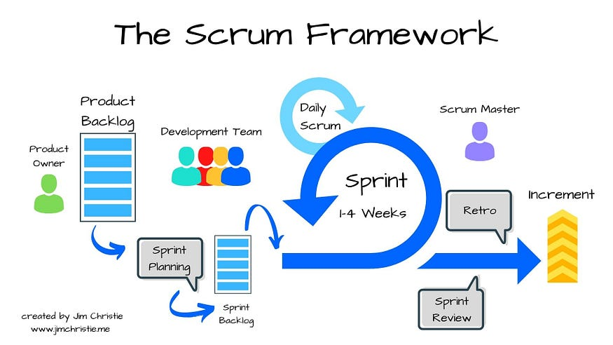
Figure 1 Scrum Framework Model
Source: https://share.google/images/Vv92JcPmkuQuWGzCL
- Product Backlog
A dynamic list of features, requirements, enhancements, and fixes and continuously updated to reflect changing needs.
- Sprint Planning
A set of time to identify the goal of the sprint which include what tasks will be completed and how the work will be accomplished.
- Sprint Execution (Development Phase)
A structured process to deliver incremental value through planned iterations, continuous improvement, and adaptive planning to efficiently achieve project goals.
- Sprint Review
To demonstrate completed work, gathers feedback, ensures alignment with the product vision and identifies improvements to promote continuous improvement.
- Sprint Retrospective
To evaluate past sprint and create a plan to address areas of improvement for the future.
- Product Increment
A new developed or refined feature that is created at the end of each sprint.

Significance of Project
The significance of Financial Management System with Machine Learning Support project that introduces Spendette lies in its potential to promote financial awareness and responsible money management among students. Through Machine Learning, the system provides personalized recommendations, empowering users to make smarter financial decisions and develop sustainable financial habits. Below is the significance of the project:
- Promotes Financial Awareness and Responsibility.
The project helps users better understand their spending behaviour by tracking both personal and shared expenses. By recording daily transactions, users become more conscious of their financial habits which avoid unnecessary expenses. Over time, this promotes a sense of responsibility and discipline in managing finances.
- Enhances Transparency in Shared Financial Management.
This project promotes transparency by providing a single platform where users can manage both individual and group expenses. The system minimizes confusion and delays in repayments by keeping a transparent record of all shared financial activities. Each member in a group can view their shared costs in real-time. This fosters a better communication among users who share common financial responsibilities.
- Adaptability with Machine Learning.
By integrating Machine Learning, the system gains the ability to analyse users’ historical spending patterns. This feature allows Spendette to offer personalized budgeting recommendations that align with each user’s financial behaviour. This adaptability not only enhances the functionality of the system but also empowers users to make smarter financial decisions.

Project Schedule
The project is expected to be completed within two semesters following the course Final Year Project I and Final Year Project II.
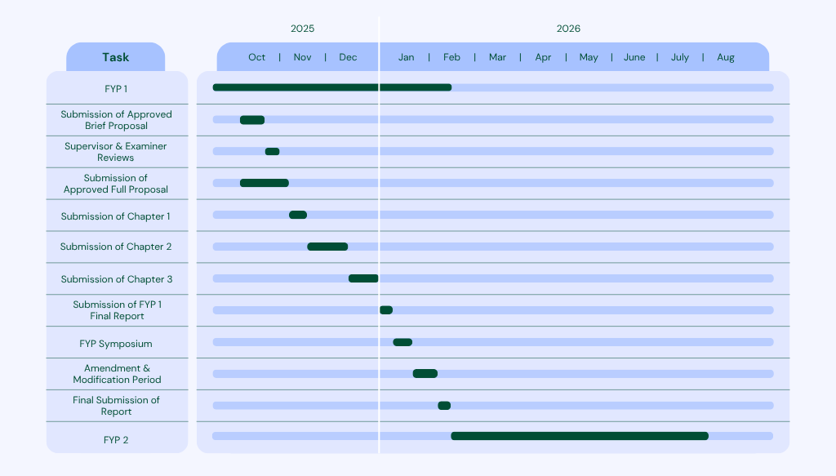
Figure 2 Gantt Chart for Final Year Project 1

Expected Outcome
The expected outcomes of the Financial Management System with Machine Learning Support project are designed to ensure that the implementation of the system meets the needs of user experience and overall efficiency. Below is the detailed description of each expected outcome:
- A fully functional web application financial management system capable of monitoring both personal and shared expenses of an individual.
This outcome focuses on developing a responsive web application that enables users to manage and track both individual and group financial activities in one platform. By integrating these functions, users can easily organize their finances, avoid duplication of records and maintain a clear overview of their personal and shared spending.

- Comprehensive financial summaries that provide users with clear insights into their spending patterns and financial transactions.
This outcome aims to generate detailed reports and visual summaries that allow users to analyse their financial behaviour effectively. The system will display spending trends, budget usage and monthly comparisons to help users identify overspending habits, manage their budgets more efficiently and make informed decisions to improve financial stability.
- A machine learning model capable of analysing users’ spending habits and generating personalized recommendations to help them plan and manage their finances more effectively.
This outcome emphasizes the implementation of a Machine Learning component that intelligently examines historical spending data to recognize patterns and detect irregularities. Based on these analyses, the system will provide personalized budgeting tips and financial recommendations tailored to each user’s spending behaviour.

References
Irby, L. (2024). 10 simple ways to manage your money better. The Balance. https://www.thebalancemoney.com/ways-to-be-better-with-money-960664
Johri, E., Desai, P., Soni, P., Jain, H., & Sanganeria, N. (2023). Expense Management System. 2023 4th IEEE Global Conference for Advancement in Technology (GCAT), Bangalore, India, 1–6. https://doi.org/10.1109/gcat59970.2023.10353348
SCRUM model for agile methodology. (2017). IEEE Conference Publication | IEEE Xplore. https://ieeexplore.ieee.org/abstract/document/8229928
Teo, T. J., Mohamad Fazli, S., Husniyah, A. R., Mohd Amim, O., Afida Mastura, & M. A. (n.d.). The Influence of Financial Knowledge, Financial Practices and Self-Esteem on Money Management Skills of Young Adults. In Malaysian Journal of Youth Studies, 23–25. https://www.iyres.gov.my/images/MJYS/2013/MJYS%20Vol%209%20Dec%202013 -25-39.pdf

